Notes for MISM Exam:

Question 1: Entity Information Category

Entity information category is the circles within a system diagrams and represents the departments within a certain system in a business or any type of process.

c) Student Information

Question 2: Leveraging Computer Hardware to improve business process

Technology can be leveraged to improve work systems and when it leverages technology it has to deploy it strategically.

b) The deployment of a network connects all departments

Question 3: Competitive advantage of a company and its connection towards leveraging of resources.

Sustainability of the products would be due to the Pre-Production subsystem that accounts on the

b) Pre-production subsystem

Question 4: Improve effectiveness of an organization.

d) The CEO made a decision to sell a business unit for which the company lacked competencies.

Question 5:

1200 dpi (Dots per inch)

A **PPM** rating on a **printer** gives you the speed at which a particular **printer** can print a page of text in black ink.

a)Laser printer

Question 6: What type of media makes a disc have a much higher density, replay quality, content retention and duplication quality.

Optical disc is likely to replace hard drives in data centers and on cloud servers, because they’re able to use 1000 times less power, hold up 10TB and life span of 600 years.

Optical Media makes it possible to create information on a disc at higher density higher replay quality better content retention and duplication quality and have more resistance towards magnetic energy.

C) Optical media

Question 7: Large computer monitor what part of hardware:

**Output hardware** category includes devices that enable computers to interact with users by transforming computer bits into human forms of interactions, such as speech, texts, sound, drawings, and pictures

d)Output hardware

Question 8: Hard drive memory system:

Magnetic storage device examples include magnetic tape backup storages (used by some mainframe computers) and the hard drives that are located in most computers.

b)Magnetic energy

Question 9: Component that stores information while computer is on:

The primary storage is the main storage component that holds small quantities of instructions, data and software programs *temporarily* (volatile), as electrical bits, for the CPU while the computer is turned on. The most common type is called a random access memory (RAM). Variations are SRAM, DRAM etc

d)Random access memory

Question 10: Video editing software slows down the speed of the computer:

The **primary storage** is the main storage component that holds small quantities of instructions, data and software programs temporarily (volatile), as electrical bits, for the central processing unit (CPU) while the computer is turned on.

c)The size of the random access memory is smaller that what the new software requires.

Question 11: Success of Zara

Zara used specific technologies (such as, software, hardware, network) were used to inform, enable, coordinate, collaborate or control specific business processes to enable Zara to achieve quick responses in the following departments: Design; Manufacturing and Logistics and Stores.

d) They leverages technology, people, information and unique procedures to create sustainable competitive advantage.

Question 12: Good representation of Moore’s Law:

For processors, Moore’s Law means that next generation chips should be twice as fast in about *eighteen* months, but cost the same as today’s models (or from another perspective, in about a year and a half, chips that are same speed as today’s models should be available for half the price).

b)The number of transistors on a CPU chip would double every two years.

Question 13: Outcomes of the impact of Moore’s law except:

d)Computers are able to use larger sizes of primary storage

Question 14: Which computer would a business use to process information for several mid-range servers:

A medium-sized computer system or server. Midrange computers encompass a very broad range and reside in capacity between high-end PC servers and mainframes. For example, IBM's Power Systems are its midrange line for both business and scientific applications.

e)Desktop computer

Question 15: Hardware that is used by ipads:

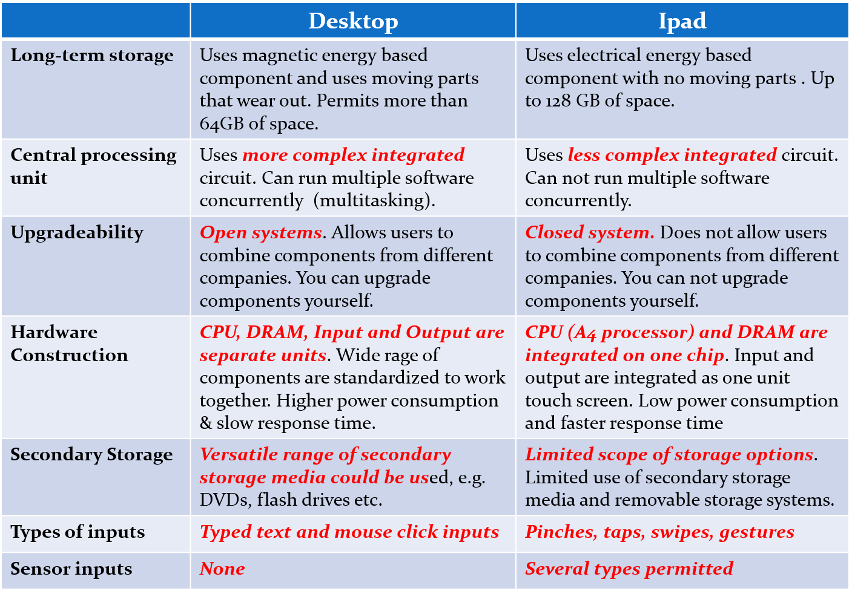

b) The processor and the primary storage are integrated on the same chip.

Question 16: Deploy new software for improving the production of news and content:

Focus on finding the software that fits best towards the company’s main interest.

c) News and content management software

Question 17: Control most of the hardware of a mainframe computer

**Middleware** software is the kind of software that facilitates the exchange of data between two application programs within the same environment, or between software that are located on different hardware and network environments. The three most common types of middleware are: (1) communication (2) database and (3) system middleware.

**Operating systems software** is a group of interdependent computer programs that provide the rules, functions, and controls needed to control computer hardware and the processing that hardware components perform.

An **application (or functional) software** is a group of independent programs that contain the rules, functions, sequence and data requirements that are needed to solve discipline-specific tasks (functional tasks), such as problems in finance, marketing, accounting, engineering, accounting, production, facilities management, health-care and so on.

A functional software contains the business steps and processes of a functional area in digital format. For example, the codified inherent process in a finance software would stipulate the data inputs are needed for a task, define the equations that are needed to compute a result, define the sequence in which the equations are to be calculated, define the results which are to be stored separately, define the results that have to be shown to the user, and define the data inputs that are required to begin to execute the task

**Utility software** is the name given to the category of software that extends the capability of the operating system.

c) Mainframe operating systems software

Question 18: Tech used for communication between ATMs and the database

An ATM is simply a **data terminal** with two input and four output devices. Like any other data terminal, the ATM has to connect to, and communicate through, a **host processor**. The host processor is analogous to an [Internet service provider](https://money.howstuffworks.com/personal-finance/banking/internet-infrastructure1.htm) (ISP).

e)All of the above

Question 19: Account receivables, account payables, new accounts creation, credit and debit balance management.

e)Accounting software

Question 20: Create a small program that would enable people to send money to each other via smart phones.

e)Applications software